NAI Cravey announces deal for 200K SF office/warehouse
Nov 01, 2010

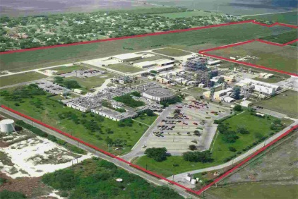
Former Celanese Technical Center
CORPUS CHRISTI, TX – Tim Lange’s real estate investment company, Double T & C properties, Inc., recently purchased the former Celanese Technical Center from Clarkwood Industrial Park, LLC. The property is located between Clarkwood Road and Rand Morgan in Corpus Christi, TX. The sale included over 200,000 square feet of office space, warehouse space and laboratory space in 11 buildings on over 100 acres. Josh Gaines with NAI Cravey Real Estate Services represented the seller.
Josh Gaines

Connect with Josh Gaines on Linkedin

